Task001::
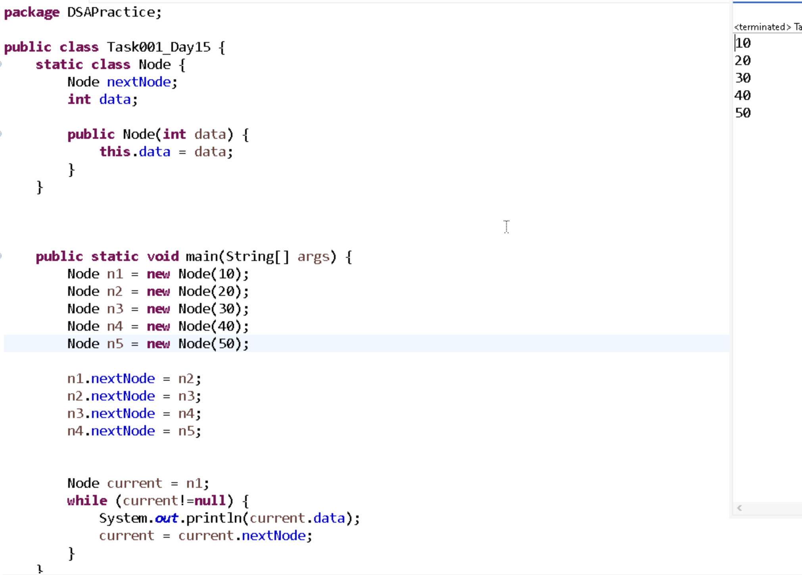

Task002::
What do you understand by traversing elements in a linked list.

Traversing elements in a linked list means visiting each node one by one from the head to the end to access or process its data.

Task003::
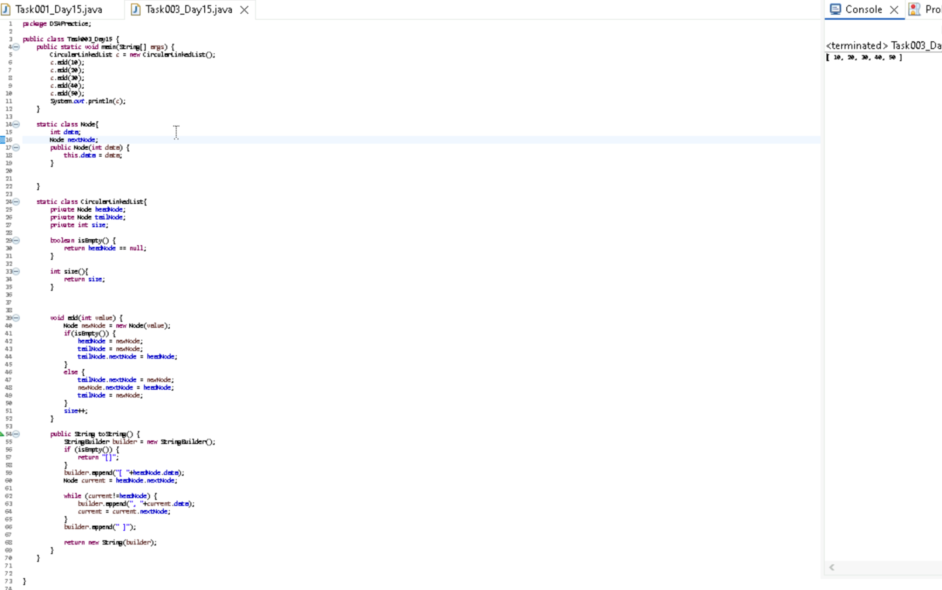

Task004::

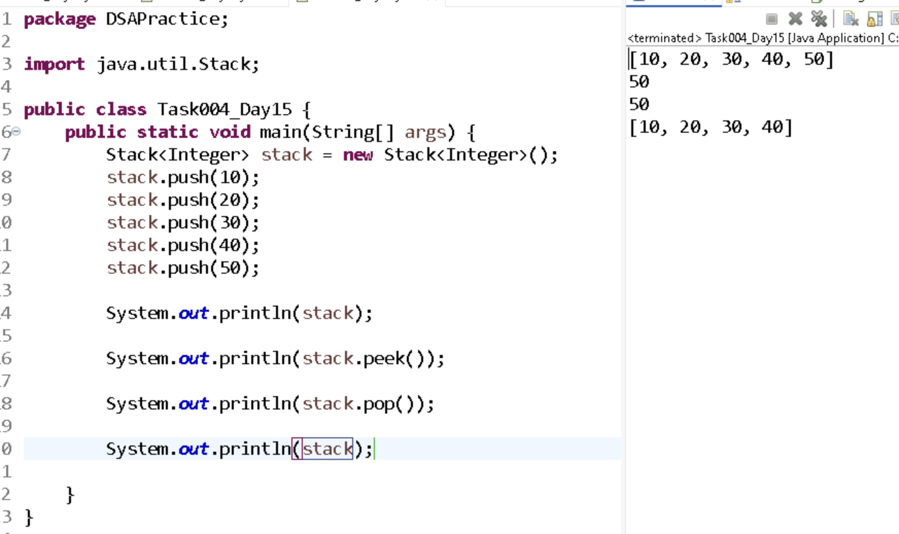

Task005::
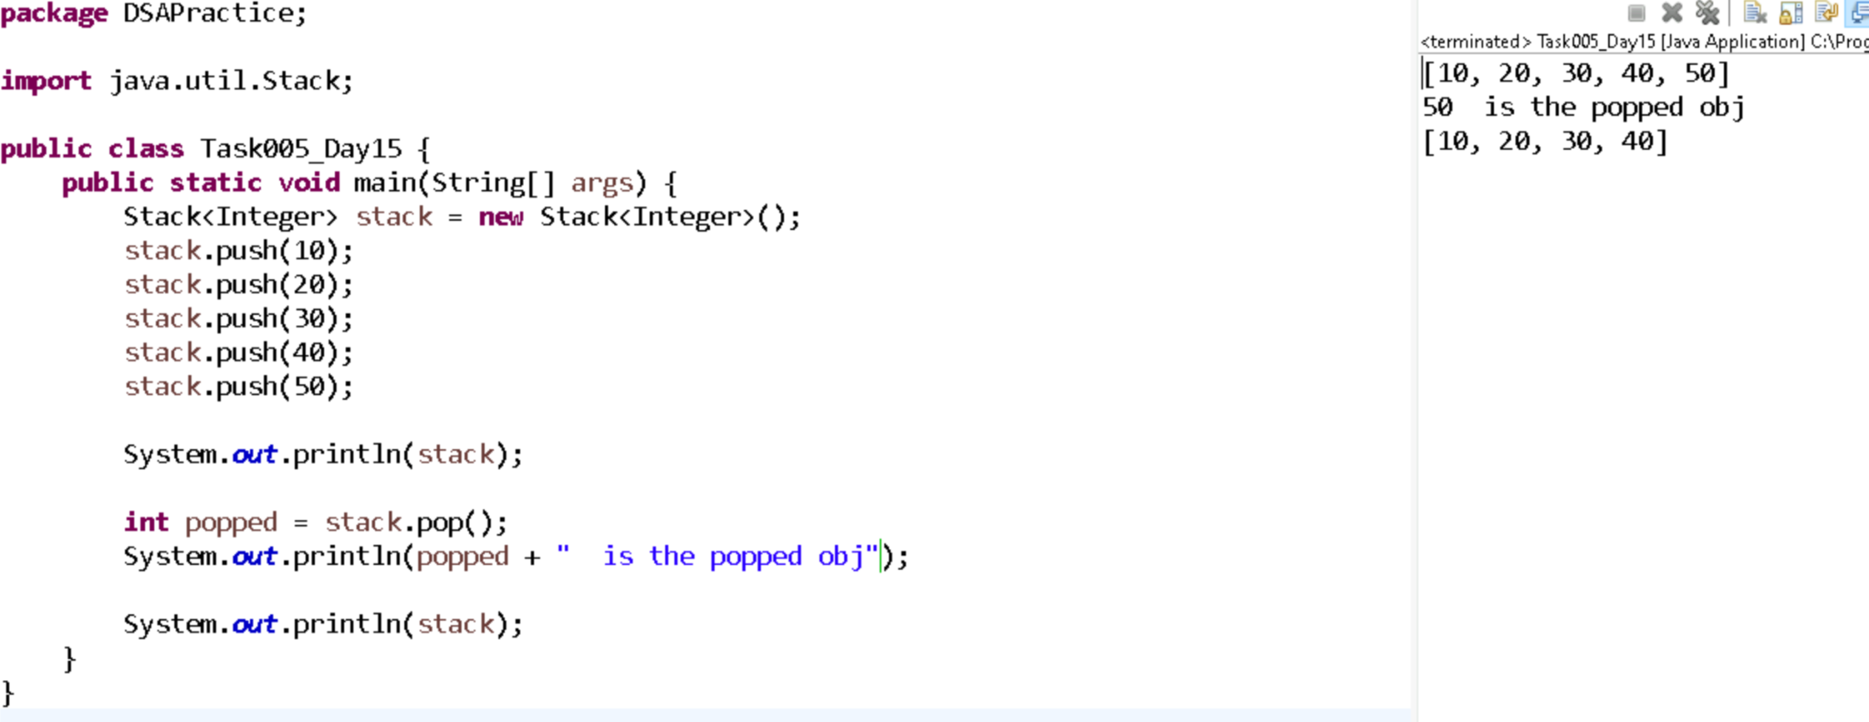

Task006 ::
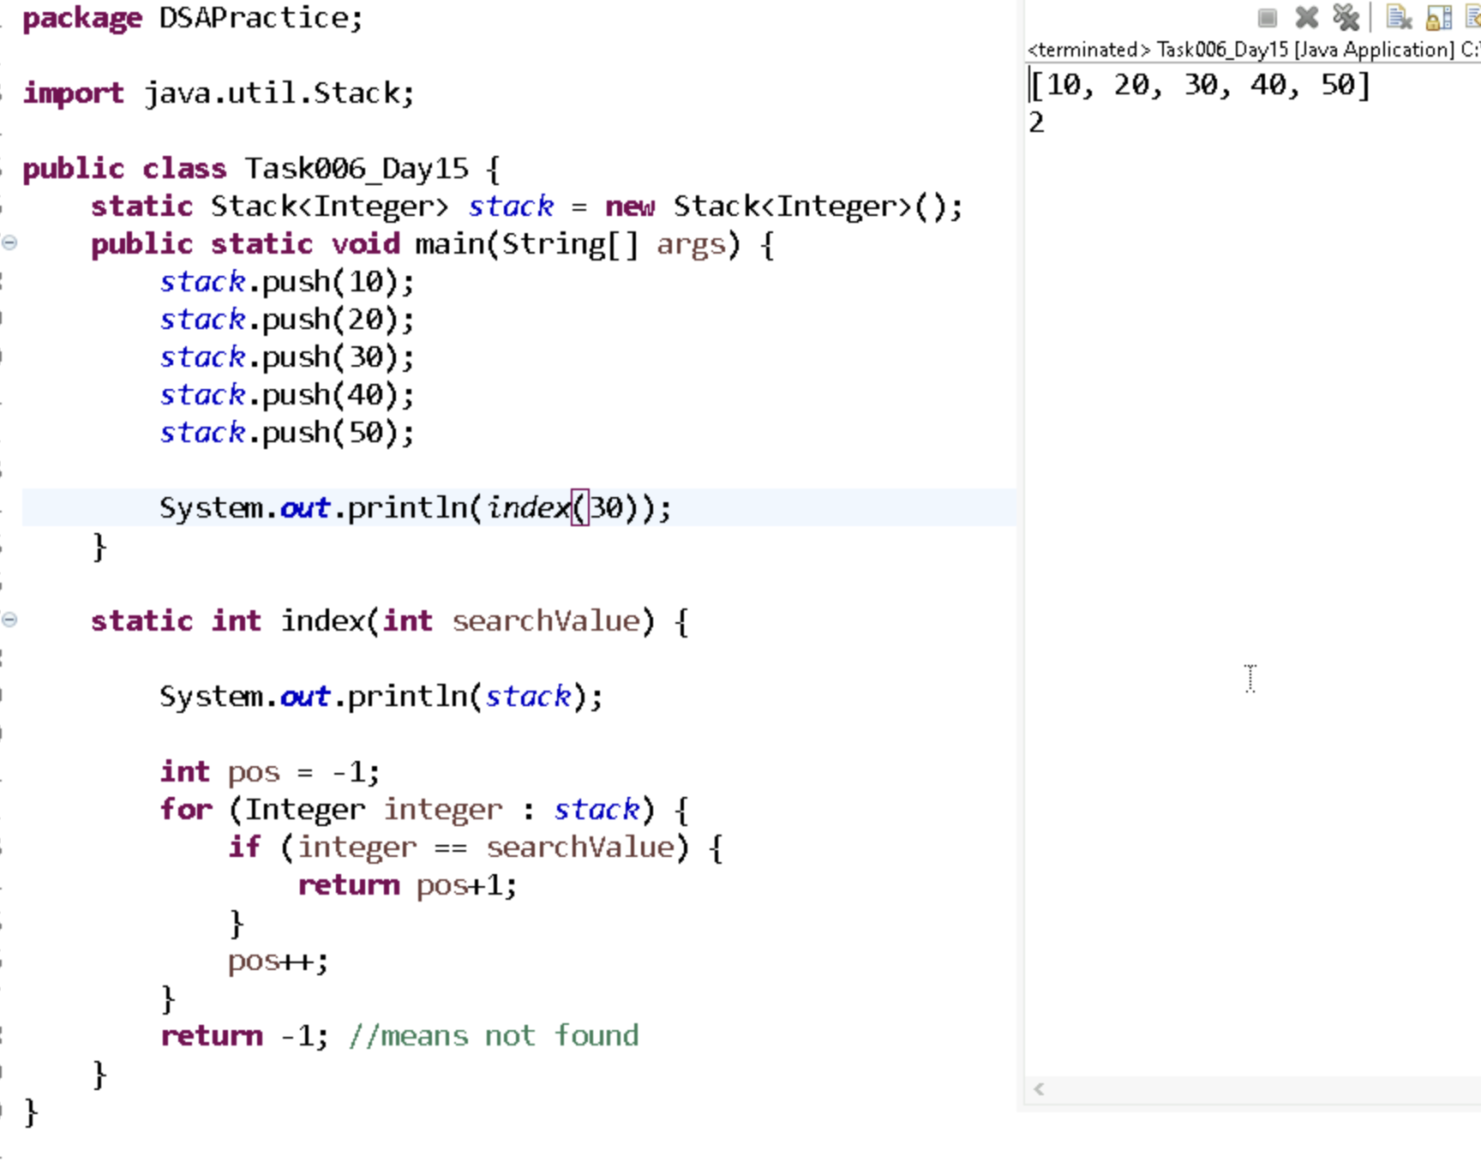

Task007::
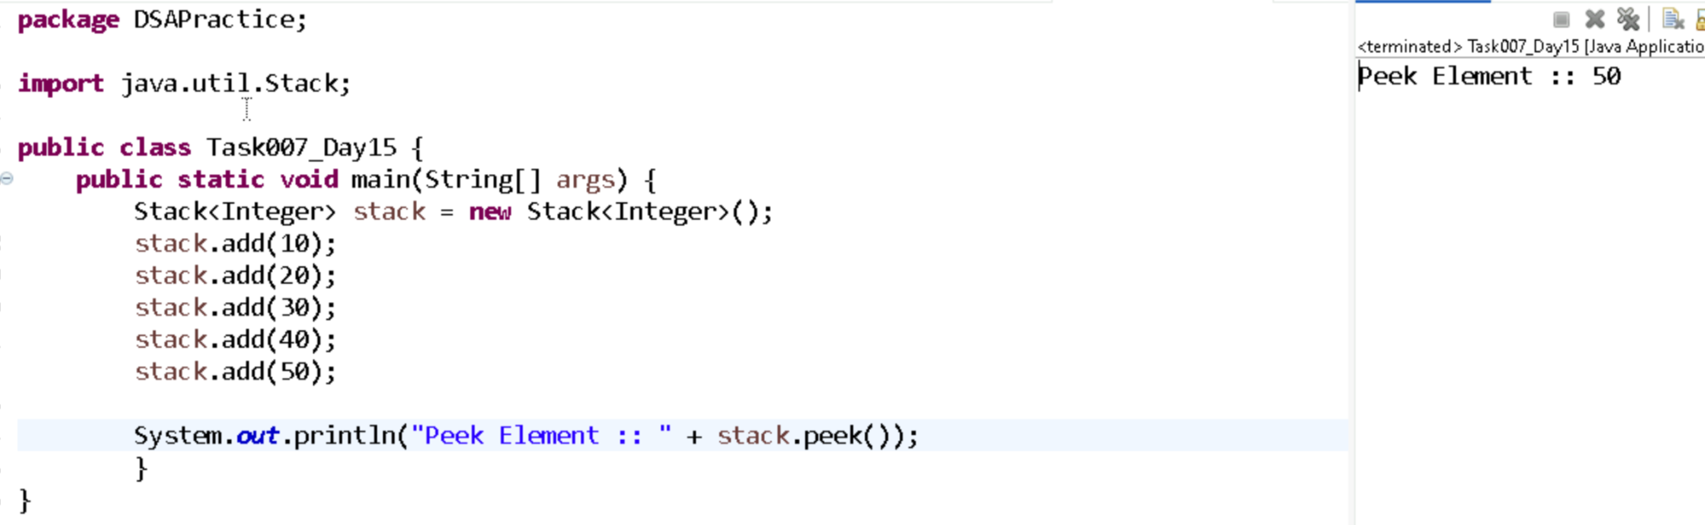
Task008::
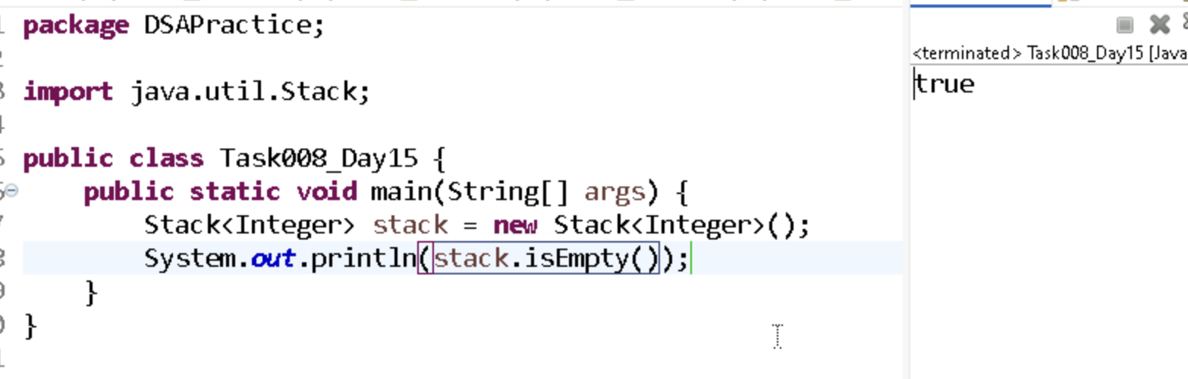

Task009::
What are the methods of the stack class
In Java, the Stack class provides methods like push(), pop(), peek(), isEmpty(), and search(). These allow adding, removing, viewing the top element, checking if empty, and searching the stack.
Ask ChatGPT

Task10::

Operation | Method | Explanation
Add element | add(e) / offer(e) | Adds element to the queue. add() throws exception if full, offer() returns false.
Remove element | remove() / poll() | Removes head of queue. remove() throws exception if empty, poll() returns null.
Peek element | element() / peek() | Retrieves head without removing. element() throws exception if empty, peek() returns null.
Check size | size() | Returns the number of elements in the queue.
Check if empty | isEmpty() | Returns true if queue is empty.
Contains element | contains(e) | Checks if element e exists in the queue.
Clear queue | clear() | Removes all elements from the queue.

Task11::

